PROJECT LOCATION MAP-DAMISCH OVER TYLER CREEK BRIDGE -07-00358-00-BR

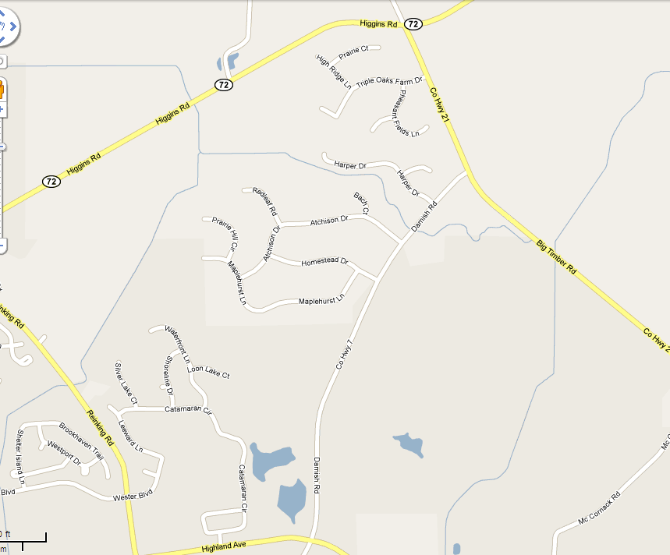
PROJECT LOCATION

